**Practice Assignment 3**

Exercise 1: Build a homepage that displays book information for readers

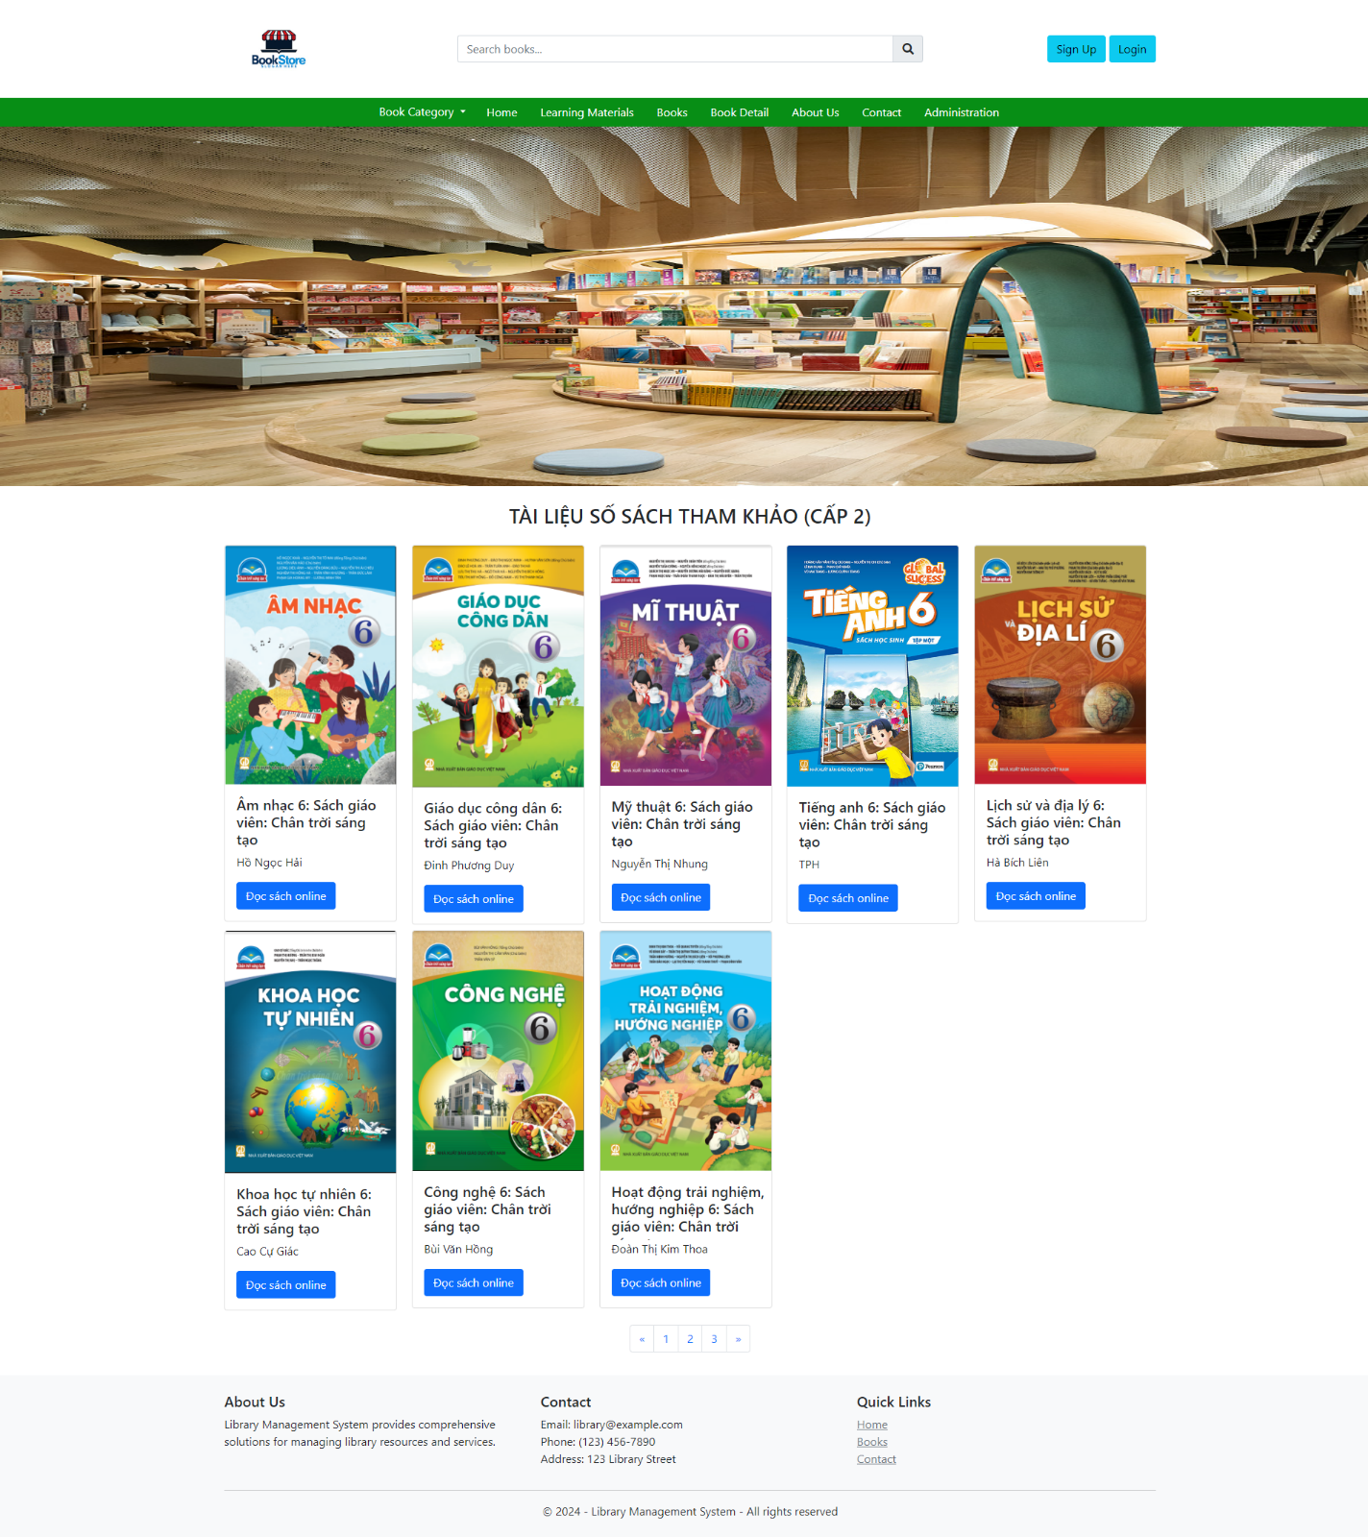

Exercise 2: With the same layout in exercise 1, design a view for the show detail information of the book

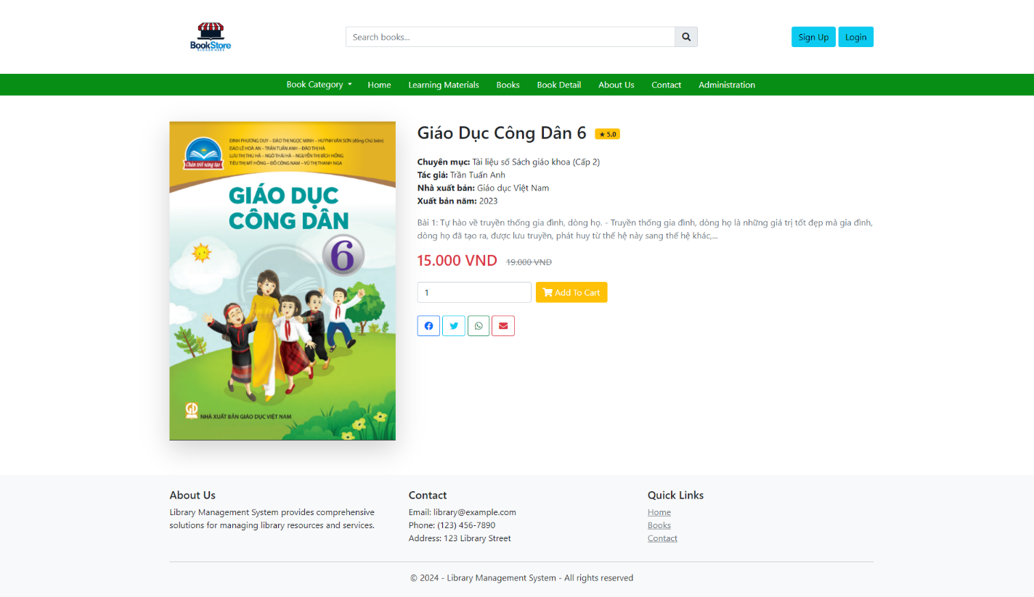

Exercise 3: Update the layout in the exercise 1 with a footer

Exercise 4: With the same layout in exercise 1, design a new page for login like a figure 3

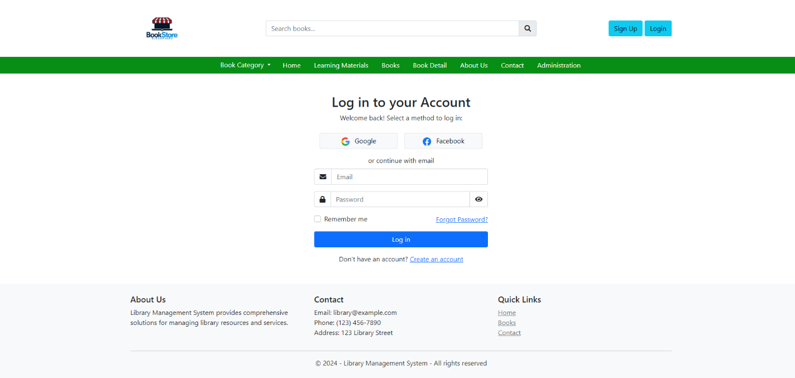

Exercise 5: With the same layout in exercise 1, design a new page for register like a figure 4

